Practical-2

Name:-Vishwajit kate

Reg. No:-2020BIT011

# Write C/C++ code to implement concept of

* Stack using linked list

Code:-

#include <iostream> struct Node {

int data; Node *next;

};

class Stack { private:

Node *top; public:

Stack() : top(nullptr) {} void push(int value) {

Node *newNode = new Node; newNode->data = value; newNode->next = top;

top = newNode;

}

void pop() {

if (top == nullptr) {

std::cout << "Stack is empty." << std::endl; return;

}

Node *temp = top; top = top->next; delete temp;

}

int peek() {

if (top == nullptr) {

std::cout << "Stack is empty." << std::endl; return -1;

}

return top->data;

}

bool isEmpty() {

return top == nullptr;

}

};

int main() { Stack stack; stack.push(1); stack.push(2); stack.push(3);

std::cout << stack.peek() << std::endl; stack.pop();

std::cout << stack.peek() << std::endl; stack.pop();

std::cout << stack.peek() << std::endl; stack.pop();

std::cout << stack.isEmpty() << std::endl; stack.pop();

return 0; }

**Output:**

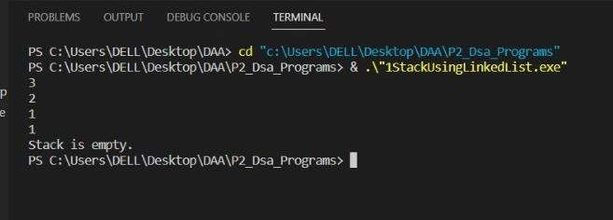

# Queue using linked list

#include <iostream> struct Node {

int data; Node *next;

};

class Queue { private:

Node *front; Node *rear; public:

Queue() : front(nullptr), rear(nullptr) {} void enqueue(int value) {

Node *newNode = new Node; newNode->data = value; newNode->next = nullptr;

if (rear == nullptr) { front = newNode; rear = newNode; return;

}

rear->next = newNode; rear = newNode;

}

void dequeue() {

if (front == nullptr) {

std::cout << "Queue is empty." << std::endl; return;

}

Node *temp = front; front = front->next; if (front == nullptr) { rear = nullptr;

}

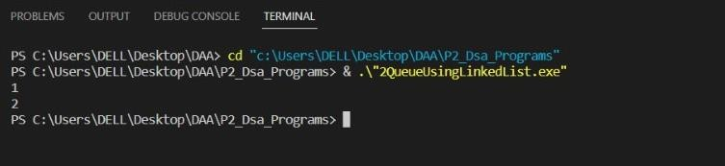

delete temp;

}

int peek() {

if (front == nullptr) {

std::cout << "Queue is empty." << std::endl; return -1;

}

return front->data;

}

bool isEmpty() {

return front == nullptr;

}

};

int main() { Queue queue;

queue.enqueue(1); queue.enqueue(2); queue.enqueue(3);

std::cout << queue.peek() << std::endl; queue.dequeue();

std::cout << queue.peek() << std::endl; queue.dequeue();

return 0;

}

**Output:**

# Doubly Linked List

# Code:-

#include <iostream> using namespace std;

struct Node {

int data;

struct Node* next; struct Node* prev;

};

void insertFront(struct Node** head, int data) {

struct Node* newNode = new Node;

newNode->data = data;

newNode->next = (*head);

newNode->prev = NULL;

if ((*head) != NULL)

(*head)->prev = newNode;

// head points to newNode (*head) = newNode;

}

// insert a node after a specific node

void insertAfter(struct Node* prev_node, int data) {

// check if previous node is null if (prev_node == NULL) {

cout << "previous node cannot be null"; return;

}

// allocate memory for newNode struct Node* newNode = new Node;

// assign data to newNode newNode->data = data;

// set next of newNode to next of prev node newNode->next = prev_node->next;

// set next of prev node to newNode prev_node->next = newNode;

// set prev of newNode to the previous node newNode->prev = prev_node;

// set prev of newNode's next to newNode if (newNode->next != NULL)

newNode->next->prev = newNode;

}

// insert a newNode at the end of the list void insertEnd(struct Node** head, int data) {

// allocate memory for node

struct Node* newNode = new Node;

// assign data to newNode newNode->data = data;

// assign null to next of newNode newNode->next = NULL;

// store the head node temporarily (for later use) struct Node* temp = *head;

// if the linked list is empty, make the newNode as head node if (*head == NULL) {

newNode->prev = NULL;

*head = newNode; return;

}

// if the linked list is not empty, traverse to the end of the linked list while (temp->next != NULL)

temp = temp->next;

// now, the last node of the linked list is temp

// assign next of the last node (temp) to newNode temp->next = newNode;

// assign prev of newNode to temp newNode->prev = temp;

}

// delete a node from the doubly linked list

void deleteNode(struct Node** head, struct Node* del_node) {

// if head or del is null, deletion is not possible if (*head == NULL || del_node == NULL)

return;

// if del_node is the head node, point the head pointer to the next of del_node if (*head == del_node)

*head = del_node->next;

// if del_node is not at the last node, point the prev of node next to del_node to the previous of del_node

if (del_node->next != NULL)

del_node->next->prev = del_node->prev;

// if del_node is not the first node, point the next of the previous node to the next node of del_node if (del_node->prev != NULL)

del_node->prev->next = del_node->next;

// free the memory of del_node free(del_node);

}

// print the doubly linked list

void displayList(struct Node* node) { struct Node* last;

while (node != NULL) {

cout << node->data << "->"; last = node;

node = node->next;

}

if (node == NULL) cout << "NULL\n";

}

int main() {

// initialize an empty node

struct Node* head = NULL;



insertEnd(&head, 5);

insertFront(&head, 1);

insertFront(&head, 6);

insertEnd(&head, 9);

// insert 11 after head insertAfter(head, 11);

// insert 15 after the seond node insertAfter(head->next, 15);

displayList(head);

// delete the last node

deleteNode(&head, head->next->next->next->next->next);

displayList(head);

}

**Output:-**

# Enqueue And Dequeue

# Code:-

#include < stdio.h > #include < stdlib.h >

// Structure to create a node with data and the next pointer struct node {

int data;

struct node * next;

};

struct node * front = NULL; struct node * rear = NULL;

// Enqueue() operation on a queue void enqueue(int value) {

struct node * ptr;

ptr = (struct node * ) malloc(sizeof(struct node)); ptr - > data = value;

ptr - > next = NULL;

if ((front == NULL) && (rear == NULL)) { front = rear = ptr;

} else {

rear - > next = ptr; rear = ptr;

}

printf("Node is Inserted\n\n");

}

// Dequeue() operation on a queue int dequeue() {

if (front == NULL) { printf("\nUnderflow\n"); return -1;

} else {

struct node * temp = front;

int temp_data = front - > data; front = front - > next; free(temp);

return temp_data;

}

}

// Display all elements of the queue void display() {

struct node * temp;

if ((front == NULL) && (rear == NULL)) { printf("\nQueue is Empty\n");

} else {

printf("The queue is \n"); temp = front;

while (temp) {

printf("%d--->", temp - > data); temp = temp - > next;

}

printf("NULL\n\n");

}

}

int main() {

int choice, value;

printf("\nImplementation of Queue using Linked List\n");

while (choice != 4) { printf("1.Enqueue\n2.Dequeue\n3.Display\n4.Exit\n"); printf("\nEnter your choice : ");

scanf("%d", & choice);

switch (choice) {

case 1:

printf("\nEnter the value to insert: "); scanf("%d", & value); enqueue(value);

break; case 2:

printf("Popped element is :%d\n", dequeue()); break;

case 3:

display(); break;

case 4:

exit(0); break;

default:

printf("\nWrong Choice\n");

}

}

return 0;

}

**Output:-**

